Introduction to Action Marketing Works Ltd

Action Marketing Works Ltd
Founded in 2012 by Mark de Quervain, Action Marketing Works comprises a core team of highly experienced professionals that work with clients to consult on, develop and implement solutions that drive incremental profit.
At its heart, the company utilises ‘Action Marketing’ which is formal business process that use a number of simple and unique tools that help companies and marketing professionals solve complex problems in cost effective and measurable ways. It ensures that those seeking solutions or behavioural changes are very clear about how they define success and how it is measured.
The business believes in being measured and rewarded on the success of the work it delivers. As such it can be considered a stakeholder in projects it is asked to work on. The company also works with start-up businesses as an equity partner.
Action Marketing Works – Our Core Services
- A full Marketing Director service that enables significant work streams and business needs to be identified and moved forward quickly and efficiently
- Business analytics
- Research, NPD, Innovation
- Digital, CRM, Social media, Mobile, Blogging
- KPI policy, incentive schemes, aligning objectives
- Strategic pricing, loyalty, membership
- Creative copywriting and design
- Sales, sponsorship, corporate partnerships
- Recommendation engines for TV, Film
- Marketing budget setting and management

The Key Tools of Action Marketing

ACTION MARKETING - The Who, What, What, What, What, What. (W,W,W,W,W,W)
WHO – Who are you talking to or trying to influence? Describe them in detail, their lives, family, give them a name(s), what do they like doing, what don’t they like doing, what they find time for and not, what do they spend their money on, what are their core values including emotions and even beliefs… a description of males aged 20-30 will not do (how often do you see that in a creative of business brief!). The Who can be applied to business to business situations as well as consumer environments.
One can actually get good results from just role playing this process. You can always back up comments and descriptions with market research and other data later. Note that the WHO can be a retailer, salesman or supplier. This is useful when using the Audience Interaction Model (AIM) shown over leaf.
WHAT – What do the WHO you have described CURRENTLY THINK, FEEL AND DO about the brand/product/service you are focusing on and WHY? It is important to be very honest here, as this section often reveals how hard a challenge is. Running this process across a number of ‘WHO’ groups will often direct you to where the easiest business opportunity lies.
WHAT – What SHORT TERM ACTION do you want them to do and WHY? This must be very clearly defined. It must not be a list of multiple or opposing actions and the WHY must also be stated here as this is the reason why someone will carry out the desired action. Being clear here will help you to measure success. You can also define a short term time parameter here. Make sure you allow people a long enough period to make the action.
WHAT – What do you want them to THINK and FEEL and DO about the product/brand/service after they have taken the short term action and WHY? This is critical in building the process of a longer term behavioural change. It also makes sure you focus on issues such as value, quality as well as your core brand and unique selling propositions. This also includes improved knowledge and understanding of your product/service/brand, without this a long term relationship will be less likely.
WHAT - Is the LONG TERM ACTION you want them to do and WHY? This is where you think about how what you have done actually changes their behaviour in the long term. Just because someone does a required action once, does not guarantee long term behaviour change. The process of LEARNING a new skill or habit requires a lot of effort on behalf of the target group.
WHAT –This simply asks what is the Return on Investment (ROI) from this change in action. This includes breakeven analysis and business case modelling/analytics. This also scales the return and prioritises the project among others in a business.

ACTION MARKETING - THE AUDIENCE INTERACTION MODEL (AIM)
The purpose of the AIM is to help you identify which relationships in a business structure can be leveraged to yield the best/biggest desired response for the least cost. AIM also helps to find new solutions to problems. The model below is the standard AIM version but will almost certainly be adapted to suit specific needs and company sales channels/structures.
You will see that there are arrows linking each of the boxes. These arrows represent the relationships both ways between the two parts concerned, you should be able to describe the relationships in detail. Like the Who, What, What… you can do this even without detailed data initially at least. You will be surprised how this reveals strengths and weaknesses in the business management chain.
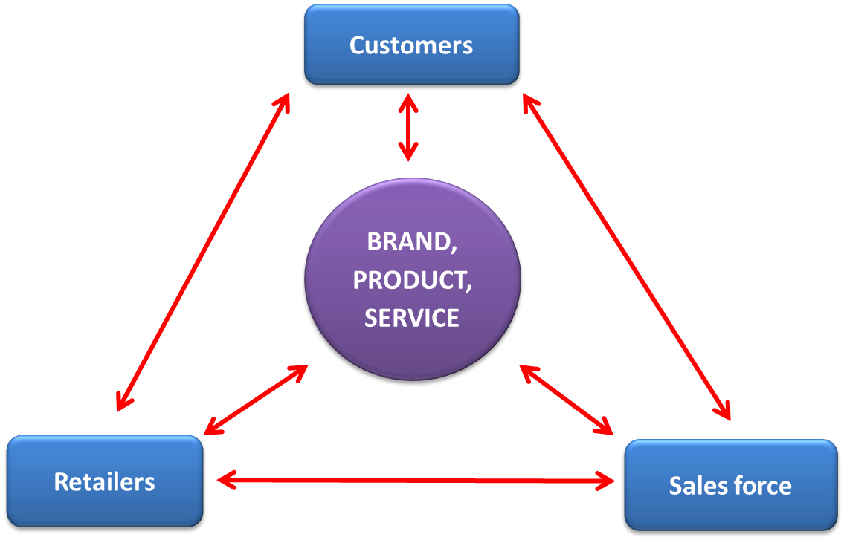

One can spend a lot of time writing each link in detail or use that chart for brainstorm sessions for problem solving exercises, either way the process will yield good results.
A specific AIM can be quickly drawn up to suit any business and their routes to market.

ACTION MARKETING – THE UNIQUE SELLING PROPOSITION (USP)
The USP is one of the most important things a company needs to identify and be totally clear about. It is this which differentiates a company, products and services with its competitors and customers.
A USP needs to be defendable and is often one of the things that drives value and prevents a company and its products or services from being a commodity or ‘me too’.
The USP can drive the company Mission and Vision and often drives priorities, investment, team structures and other areas such as pricing strategy.

ACTION MARKETING – THE SINGLE MINDED PROPOSITION (SMP)
Far too many marketing activities are often confused about what they are actually trying to tell the target audience and what they are asking them to do or sell. This is because there are often far too many messages all fighting for attention on one communication.
It is vital that for any piece of action based marketing, the SMP is clearly defined and described in words BEFORE any creative work is started. Agreeing a SMP is often the one process that takes the longest among teams and generally is the one thing that sparks the most discussion.

Having a SMP will also prioritise you messaging.

The SMP is often derived from using the W,W,W,W,W,W…. and the AIM.

ACTION MARKETING – CRITICAL SUCCESS FACTORS (CSF)
Critical Success Factors are things a company MUST succeed in. Failure to do so will almost certainly put the company at risk. They also have an important role in aligning the company objectives and rewards so that everyone in a business is pulling in the same direction. They focus a business on its core priorities and they also help deliver the Mission and Vision.

Business KPIs are closely linked to CSF as are resourcing priorities. CSF’s can change over time once they have been delivered.

ACTION MARKETING - The Relationship between Knowledge, Intent and Incentive:
There is certainly a direct link between knowledge and intent to purchase. If your target audience does not know something how can they react to it? How can they decide whether they like it or not?
It is not uncommon that companies assume their customers know about something but in reality they don’t (or at least to the extent they think they do), a good example in cinema is the promotion of stadium seating where there is a huge gulf between what cinema companies assume their customers understand vs. what they actually do (they think plastic flip seats you get in stadiums).
Then there is the link between awareness and understanding – these are different things. Awareness does not mean that an action will take place and as such awareness as a measure of success may not be the most effective. The ideal pre-action measure is Intent.
The blue diagonal line in the chart below shows the relationship between ‘incentive strength’ and level of intent. The lower the intent the more likely a stronger incentive is required and applied particularly when awareness/knowledge is already high. The sector numbers relate to various states of knowledge and intent which can be examined further in follow up meetings.
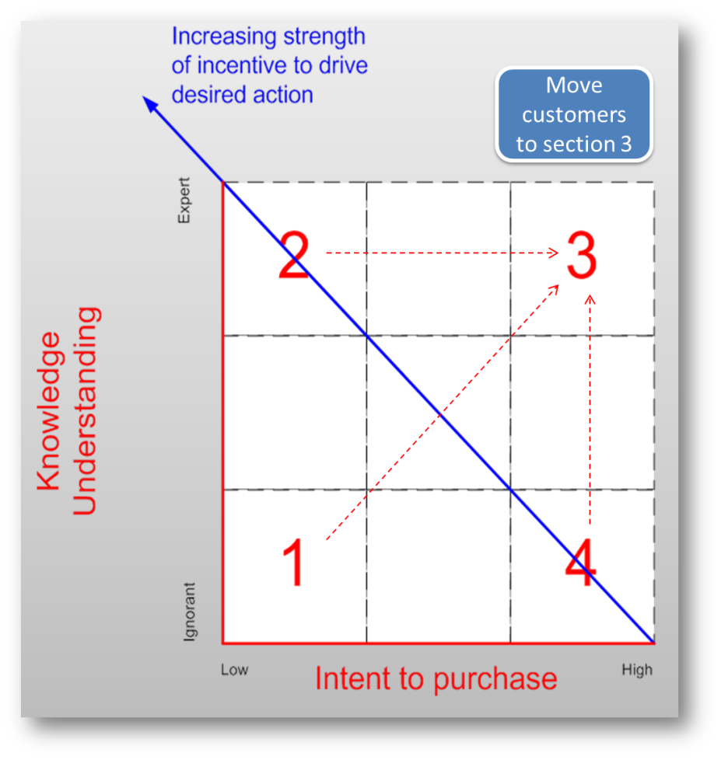

Sector Comments – Intent, Knowledge Chart
Sector 3 | The best customer knows probably as much, if not more than you do about your brand/product or service. | High intent requires no real incentive other than perhaps recognition. Brand Advocate, probably be first to sign up for loyalty programme. Probably not price sensitive.
Sector 4 | Good customer but perhaps buying for the wrong reasons based on lack of knowledge or could become alienated and be disappointed particularly if their expectations not met. | High Intent – possibly not brand loyal. Incentivise them to get to know the product/service more. Move them to  sector 3
Sector 2 | Very knowledgeable but low intent to buy – why? Misunderstanding of information, your product/service not meeting their needs. | Incentivise them to purchase – offer a strong incentive as knowledge not doing the trick. Probably not brand loyal. Try and move them to sector 3 through trial.
Sector 1 | Totally ignorant about product and service – lack of knowledge drives lack of intent to purchase. Drive knowledge first. Identify their ‘need’ and deliver a meaningful message to get on their ‘radar’. | Little or no intent – offer incentive if improving knowledge does not work. Move them diagonally to sector 3 (probably in stages).

Action Marketing – Pricing, Membership and Loyalty
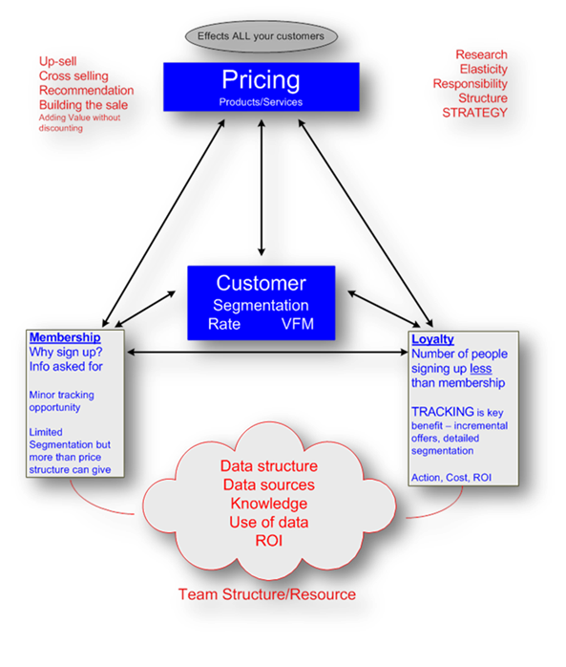
The chart below shows some of the relationships and key factors that link Pricing, Membership and Loyalty. The commentary touches on these in brief.
The importance of a company having a proper and strategically reviewed pricing structure in place is critical to optimising profitability of a business, its products and services. Pricing impacts all customers, so any changes made will generally have significant impact.
Pricing drives customer behaviour (value for money perception) and often competitor action/reaction. Poor pricing strategy often results in expensive marketing activity being carried out that tries to overcome pricing issues which would be better fixed by changing the core pricing or changing the structure. Good pricing strategy delivers successful upselling and cross selling.

It is important that a business understands price elasticity of demand (PED) which is a measure used in economics to show the responsiveness, or elasticity, of the quantity demanded of a product or service to a change in its price. More precisely, it gives the percentage change in quantity demanded in response to a one per cent change in price (while holding constant all the other determinants of demand, such as income). It was devised by Alfred Marshall.
Customer Loyalty is impacted by pricing. Value for money perception is as well which in turn is also impacted by levels of knowledge and awareness (ref previous chart).
Membership Schemes primarily exist to data capture specific details about customers, enabling the company to ‘talk’ to them and carry out Customer Relationship Management (CRM). The number of customers signing up to a membership scheme is generally a lot fewer than the entire customer base but often a significant number. Some companies require membership to purchase which enables them to data capture everyone. Companies often offer poor reasons for customers to ‘sign up’ or over-state the benefit of membership and so fail to deliver against their promise. A lot of membership programmes are platforms for pushed messaging to customers.
When talking about customer loyalty, a default solution quite often is a structured loyalty programme such as Nectar or Tesco Clubcard. As with membership, the numbers of customers who sign up to a loyalty programme tend to be fewer than that of membership and far fewer than the total customer base. As such, companies often put enormous effort and resource into loyalty programmes that actually talk to and engage with, a fraction of their base (often those customers who are most loyal and already engaged).
The key benefit to a loyalty programme is tracking purchases and therefore the ability to deliver refined and sophisticated CRM. It is not unusual that the ROI (Return on Investment) derived from loyalty programmes is not as clear as they should be. Rewarding loyalty can be an expensive business and running complex loyalty programmes can be difficult and costly to change, so it is very important to be clear on the objectives and deliverables of a programme before launching one.
Pricing is a big area well beyond the scope of this introduction. Action Marketing Works can help optimise your pricing, membership and loyalty strategies.

Disruptive Communication and Behaviour Change
During an average day we are bombarded with selling messages from many sources. The estimates of how many vary considerably but in quantum terms it runs into the thousands.
We are all very good a filtering out messages with only a small percentage, probably less than 1% or ½% getting through to our sub conscious and conscious minds.
The human brain pays particular attention to things that it is focusing on and is incredibly efficient as ignoring anything else that gets in the way of this concentration, particularly if it is unrelated or incidental to the primary goal.
A good demonstration of this is a video of basketball players with two teams, one wearing white and the other wearing black shirts. When viewers are asked to count the number of times the ball is passed between the white shirt players the brain becomes highly focused on this task and ignores the fact that during the short video a person joins the teams wearing a gorilla costume. In group sessions most people manage to correctly or get close to the number of passes the white team has made but when asked – did you see the gorilla? – the majority of people claim not to have seen it.
This is a simple and fun test to do on people but it neatly demonstrates the point about the fact that the human brain works incredibly well when focused at the expense of other non-relevant external things.
When we ‘need’ something or are ‘interested’ in something a similar process occurs. We become focused and more receptive to messages and information. The human brain likes to receive knowledge or learning.
Creatures of Habit – Line of least resistance
We are creatures of habit, we like routine (to a point) as it is learnt behaviour that provides a feeling of comfort reward and reassurance. We also quite lazy and like taking or finding the line of least resistance – maximum reward for the minimum of effort. Any behaviour that is changed through bad experience is incredibly hard to change as the learning has been from actual effort which has resulted in unsatisfactory outcomes. From a Marketing point of view these situations are critical to bear in mind when devising activity that is designed to generate a behaviour change.
Anything that tries to change our normal behaviour can create stress which the mind tends to resist. The bigger the change and the increased effort needed and the potential more resistance we put up. Personal risk is something that generates the biggest response as it taps directly into our survival instinct. Health, injury, safety, financial, hunger, thirst etc risks are good examples of this.

The daily behaviour of people and some of its routines can become quite entrenched to the extent that strong habits can develop such as nail biting, smoking, drinking etc where other the behaviour can be rewarded or strengthen with the additional benefit of addictive chemicals that magnify the reward. But even having to always have a Starbucks coffee before or when arriving at work, or sleeping on a train, or having popcorn when watching a movie, having a beer with a football match …. Are milder examples but never the less can be quite powerful? We even like rewarding ourselves with a sticky bun or similar after going to the gym (when we know that the calories we burnt used is probably less than those in the bun we are about to eat).
Habits and behaviour is often underpinned by cultural or sub group influences such as what ones friends do. This can result in ‘unacceptable behaviour’ in the larger society being seen as acceptable or normal in the sub groups. This is reinforced by the fact that we tend to spend time with ‘likeminded people’. In fact recommendations from a person’s friends is a very potent marketing tool that is seen as being very effective as it actually drives a chemical reaction in the brain with the release of endorphins (xxxxx). The idea of who do you believe the most will generally be friends/family opposed to a brand.
The more a behaviour change is accepted externally or post rationalised as acceptable internally, the quicker it becomes normalised. This can create a trend of behaviour change over time which continually becomes normal and acceptable (the trend can be good or bad)
So what has all this to do with marketing and the Action Marketing process? In short, marketers need to find ways of presenting messages that are disruptive, in the sense that they actually get noticed and then actioned. The more they get noticed the more likely a change of behaviour can be generated.
Getting a person to switch from one behaviour to another requires a replacement behaviour to be put in its place that is seen as better, more rewarding, easier etc. You can get a person to stop biting their nails if you can give them something else to do with their hands (manicuring for example particularly at the time when they bite their nails the most).
Repetitive Behaviour
The more often we do something the better the chance a new learning is secured and strengthened. In the extreme it is a fact that people need to spend on average 10,000hrs doing something to become an expert (practice makes perfect!).
The majority of things we try to sell and ask people to do clearly are not at this level but it demonstrates the fact that to secure a new behaviour we will more than likely have to get a person to do it more than once. So Action Marking looks into not one action but multiple action activity.

